**Multi-hop routing in 5G Vehicular Networks using RSU based infrastructure**

**PROJECT REPORT**

***Submitted in the partial fulfilment of the requirements***

***for the course***

**CSL7310 Vehicular Adhoc Networks**

***by***

Garvit Chugh (M20CS018)

Samanyu A Saji (M20CS013)

Umang Barbhaya (M20CS020)

Dipinti Manandhar (M20CS017)

***Submitted to,***

Dr. Debasis Das



DEPARTMENT OF COMPUTER SCIENCE & ENGINEERING

INDIAN INSTITUTE OF TECHNOLOGY, JODHPUR

JODHPUR, INDIA

**ABSTRACT**

In this study, a greedy algorithm has been proposed which is the maximum predicted connection survival algorithm (MPCS), based on a hierarchical structure. In order to provide vehicles that can dynamically select clusters while driving, and reduce the additional costs incurred by the clustering process while multi hopping delivery system is in use. LLT-based predictive quantitative indicators are used in cluster selection, and the angle of travel direction and the reward and penalty for connection prediction of the same cluster are introduced to provide a basis for vehicle cluster selection.

The performance analysis is done by comparing the results with three other multihopping algorithms, which are,

1. Lowest Identification Clustering (LID),
2. High Connectivity Clustering (HCC), and
3. Maximum Packet Collection (MPC)

**Chapter-1**

**Introduction**

Vehicular Ad Hoc Net-work, VANET, To provide services, an instant and efficient communication system is necessary, and the current communication methods are mainly divided into Vehicle-to-Infrastructure, Vehicle-to-Vehicle [1][2], However, the methodology to deploy the two is worth considering. If all vehicles communicate directly with the infrastructure, the infrastructure will receive a lot of interference and excessive redundant information when receiving signals.

It is often required to disseminate a safety message to vehicles several kilometres away, and one-hop communication is not sufficient enough to cover the entire target region. Hence, multi-hop routing techniques in have been recently proposed to facilitate the safety message dissemination process. Due to the highly dynamic nature of VANETs, traditional routing techniques are often highly inefficient and exhibit a low throughput.

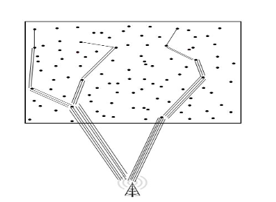 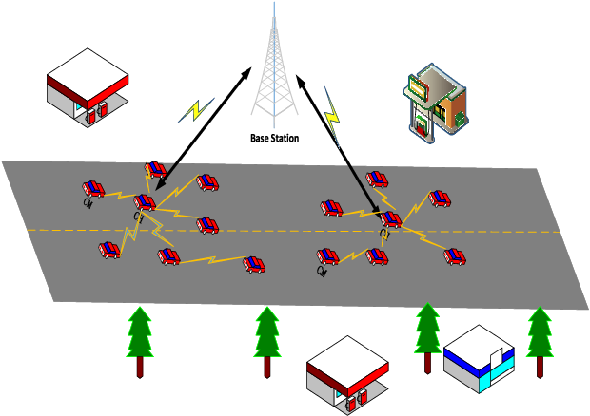

Fig. 1. Multi hop broadcasting

Therefore, broadcasting routing protocols are generally preferred for information dissemination in VANETs, and if neighbouring vehicles can sort out each other’s driving information, then designating vehicles to communicate with infrastructure can reduce information redundancy and improve communication quality.

Due to the high mobility and uneven distribution of vehicles, it is not easy to establish stable communication management. However, the clustering method has been proved to be quite effective in improving reliability and scalability [4]. In the cluster, a cluster leader is responsible for managing the communication of members in the cluster, and is responsible for communicating with the infrastructure and other cluster leaders. However, the original clustering method is designed for mobile ad hoc networks (MANET).

Due to the fast movement, changing topology, restricted movement, extremely high extensibility, fragile linearity between nodes, etc. [5], the cluster algorithm originally used in mobile networks must be adjusted according to its characteristics. This study will propose a Greedy Algorithm and Hierarchical Structure to reduce the additional burden of clustering, and use the Maximum Predicted Connection Survival time algorithm (MPCS), as a quantitative indicator for nodes to perform various cluster activities.

**1.1 Problem Statement**

Multi hop routing algorithms are being used to disseminate multiple packets in a large environment, however, there is a need for better delivery of these packets. Due to the high mobility and uneven distribution of vehicles, it is not easy to establish stable communication management.

However, the clustering method has been proved to be quite effective in improving reliability and scalability. Therefore, With the help of this project, MPCS algorithm will be implemented which tries to improve the packet delivery in multi hopping with the help of clustering.

**1.2 Objective and Scope**

With the help of this study and project, the following aims are to be approached,

1. Use a hierarchical structure to achieve a certain degree of dispersion, reduce the additional transmission cost between Cluster Head and Cluster Members due to clustering
2. Propose quantitative indicators based on connection survival time and behaviour direction as a basis for node status changes and cluster selection
3. By timing cluster selection, the best connection between nodes can be maintained
4. The first time the cluster tests the connection with the cluster members to maintain the overall connection quality of the cluster

**Chapter - 2**

**About the System**

An assumption has been made that each car has a unique identification code (Identity Code, ID) and is equipped with on-board unit (Onboard Unit, OBU), GPS(Global Positioning System, GPS) to get the current position, speed and direction of movement.

Another assumption made is that each car will be assigned a status, namely:

1. Initial Node (IN),
2. Cluster Member (CM),
3. Cluster Header (CH)

and will switch status after a specific event occurs after Tcollect expires.

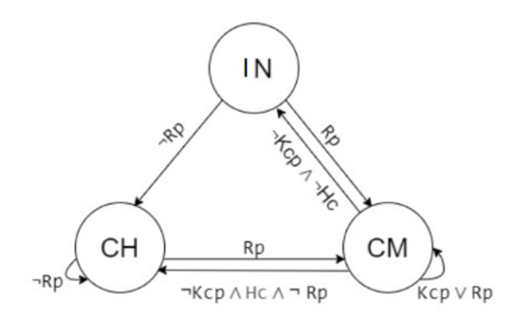

Fig. 2. Hierarchical structure between CH, CM, and IN for dispersion.

And as shown in the Figure, CM is divided into parent and child. Parent is responsible for transmitting the driving information of itself and children to CH. This hierarchical structure can achieve the effect of decentralization. Each parent only needs to maintain children within its one-hop range. Nodes joining and exiting do not need to be approved by CH, only need to establish a connection with the parent. This method can greatly reduce the communication with the CH through multi-hop, and there is no need to notify when the parent changes the cluster due to the change of the parent. children.

**2.1 Methodology**

The initial state of all nodes is IN. A Tcollect is performed before the node starts to move, and invitation packets are received during the timing process. When the vehicle Tcollect expires, the Maximum Predicted Connection Survival time algorithm (MPCS) algorithm is performed, in which the vehicle will make different decisions based on its own state, PCM, PCH and Pd.

If the status of the vehicle is IN, invitation packets from other vehicles are received during the Tcollect process, and the Cluster Selection (CS) algorithm is performed to select the vehicle with the largest predicted connection value and its connection, and join This cluster will update its status to CM. If it does not receive any invitation packet, it means that there is no existing cluster nearby to join, then a new cluster will be established to establish a connection with the infrastructure, and the status will be changed to CH.

If the vehicle status is CM and packets from CM or CH are received during Tcollect, the cluster selection (SC) algorithm (2) selects the most suitable newParent. If newParent is not the current parent, it will be disconnected from the original parent. Connect and connect with newParent, and join the cluster where newParent is located, otherwise the connection with the original parent will be maintained, so that the vehicle can maintain the connection with the most suitable parent, and the CH does not have to be particularly affected by poor connection that affects the overall cluster quality CM does maintenance. If no parent's packet is received during the period, and no invitation packet from other clusters is received, it means that the sub-cluster has left the main cluster. A new cluster is created, the status is changed to CH, and a connection is established with the infrastructure.

If the vehicle status is CH and an invitation packet from other clusters is received during the period, the most suitable newParent will be selected through the cluster selection (SC) algorithm 2. If it is determined that the maximum member limit and layer limit of the cluster will not be exceeded after the merger, Then compare Upper_LLT, merge the node with the smaller Upper_LLT to another node, and change the status of the joining node to CM.

The following table consists details about the various symbols being used in the implemented algorithm, which is mentioned after table 1.

Table 1. Symbols used in algorithm

|  |  |
| --- | --- |
| Symbol | Meaning |
| Time | Packet Sending Time |
| Ci | Vehicle Number |
| X | Longitude of Vehicles |
| Y | Latitude of Vehicles |
| Vx | East-West Speed |
| Vy | North-South Speed |
| Layer(i) | Number of cluster layers |
| State(i) | Vehicle status |
| Upper_LLT(i) | Average LLT between ancestors of vehicle i |
| NodeNum(i) | Current number of cluster members |

Algorithm 1: Maximum predicted connection survival time (MPCS)

> > IF C.Tcollect is Time Up OR Force THEN

> > IF C.state is “IN” THEN

> > IF C receive pak from other cars THEN

> > LET newParent_list TO CS(C)

> > FOR newParent IN newParent_list DO

> > IF two clusters could be merge THEN

> > CAR_CONNECT(C, newParent)

> > C join newParent.cluster

> > C change state to CM

> > LET join_flag TO TRUE

> > BREAK

> > END IF

> > END FOR

> > ELSE

> > LET newClu TO CLUSTER_CREATE(C)

> > C join newClu

> > C change state to CH

> > END IF

> >

> > ELSE IF C.state is “CM” THEN

> > IF C receive any pak THEN

> > LET newParent_list TO CS(C)

> > FOR newParent IN newParent_list DO

> > IF two clusters could be merged AND newParent is not C.child THEN

> > CAR_DISCONNECT(C, parent)

> > CAR_CONNECT(C, newParent)

> > C join newParent.cluster

> > END IF

> > END FOR

> > ELSE

> > LET newClu TO CLUSTER_CREATE(C)

> > C join newClu

> > C change state to CH

> > END IF

> >

> > ELSE IF C.state is “CH” THEN

> > IF C receive pak from other cluster THEN

> > LET newParent_list TO CS(C)

> > FOR newParent IN newParent_list DO

> > IF two clusters could be merge THEN

> > IF newParent.Upper_LLT > C.Upper_LLT THEN

> > CAR_CONNECT(C, newParent)

> > C join to newParent.cluster

> > C change state to CM

> > BREAK

> > ELSE IF newParent.Upper_LLT < C.Upper_LLT THEN

> > CAR_CONNECT(newParent, C)

> > newParent join to C.cluster

> > newParent change state to CM

> > BREAK

> > END IF

> > END IF

> > END FOR

> > END IF

> > END IF

> > END IF

**2.2 Theory and background**

**2.2.1 Cluster Selection**

In previous section, the term cluster selection has been used, which is an algorithm performed to select the vehicle with the largest predicted connection value and its connection, and join This cluster will update its status to CM. Refer to table 2 for definition of various symbols being used for the formulas used in this study.

Table 2. Symbol and definition for the formulas

|  |  |
| --- | --- |
| Symbol | Definition |
| Tcollect | Timer, during which the vehicle will transmit and receive packets, and perform the MPCS algorithm when it expires |
| Ci | Identification code of vehicle i |
| State(i) | State of vehicle i |
| Δx | The difference in the x-coordinate distance of the two cars |
| Δy | The difference in the y-coordinate distance of the two cars |
| ΔVx | The speed difference between the two cars in the x direction |
| ΔVy | The speed difference between the two cars in the y direction |
| Δθ | The angle difference between the two vehicles |
| TR | Maximum packet transmission range |
| Clu(i) | Cluster number of vehicle i |
| Layer(i) | The number of cluster layers where vehicle i is located |
| Pd | Record of failed packets received during Tcollect |
| PCM | Receive packets from CM vehicles during Tcollect |
| PCH | Receive packets from CH vehicles during Tcollect |

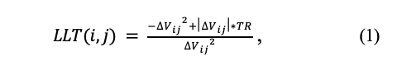

Refer to the formula of LLT (1) [8], in this formula we are adding the behaviour direction and other factors as the quantitative index when the node selects the cluster, and use the cluster selection algorithm 2 to obtain the newParent_list, and implement it based on the cluster head backup method (BackUp Cluster Head, BUCH). )[6]'s newParent_list backup scheme, when the child and the original parent are disconnected unexpectedly, the next parent in this list can be cached.

In the following formulas, Adding Upper_LLT(2) equation to the original LLT(1) equation will help judge the relative survival time of the predicted connection between the vehicle and newParent (3) equation:

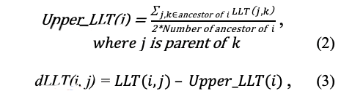

If the angle between the directions of the two vehicles (∆θ) is within a certain range, an additional reward will be given in proportion to the angle between the directions, and if it is in the opposite range, a penalty will be given as mentioned in (4) equation:

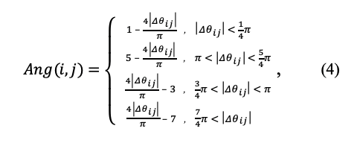

In order to reduce cluster changes, if two cars are in the same cluster, additional rewards will be obtained using the (5) formula:

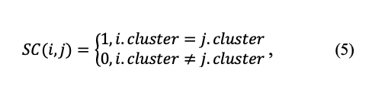

Further, in cluster selection algorithm, the difference between the received invitation packet and the failed transmission packet is the original predicted connection survival time argument (pcs), which is represented by (3), (4), ( 5) formula for rewards and punishments. In order to adjust the degree of influence caused by each formula, the parameters of LLTF, ANGF, and SCF are added.

Algorithm 2: Cluster Selection algorithm (SC)

> > LET cand_map TO EMPTY_MAP

> > FOR Cn IN C.Pcm, C.Pch DO

> > IF Cn NOT IN cand_map THEN

> > LET pos_pak TO pak number sent from Cn

> > LET neg_pak TO pak number drop from Cn

> > LET pcs TO pos_pak – neg_pak

> >

> > IF dLLT(C, Cn) > 0 THEN

> > pcs += ln(dLLT(C, Cn)) * LLTF * pcs

> > ELSE IF dLLT(C, Cn) < 0 THEN

> > pcs -= ln(-dLLT(C, Cn)) * LLTF * pcs

> > END IF

> > pcs += Ang(C, Cn) * ANGF * pcs

> > pcs += SC(C, Cn) * SCF * pcs

> > cand_map ADD {Cn : pcs}

> > END FOR

> > RETURN cand_Map

**2.2.2 Connection Maintenance**

The connection between vehicles may be degraded due to unexpected events. At this time, disconnecting from the child and forcing the child to create a new cluster or join another cluster is better than continuous but inefficient transmission.

With the parent’s regular check on the child, if the connection quality between the parent and the child is less than two standard deviations from the connection quality between the parent and the other children, the connection will be disconnected and the child’s Tcollect will be forced to expire. After the child establishes a cluster or establishes a connection with other slaves, it disconnects from it. The process uses connection maintenance algorithm 3:

Algorithm 3: Connection Maintenance algorithm (CM)

> > FOR child in C.childrenList DO

> > LET μ TO average LLT of other children

> > LET σ TO standard deviation LLT of other chil-dren

> > IF LLT(child, C) < μ – 2* σ THEN

> > make child GOTO EVENT_TIMEUP(Force)

> > CAR_DISCONNECT(C, parent)

> > END IF

> > END FOR

**Chapter - 3**

**RESULTS AND DISCUSSION**

Two software have been used in order to simulate the roads of Delhi, India as shown in figure 3, which are namely, OpenStreetMap[11] and SUMO[12]. The intersection of Connaught Place in Delhi is being simulated as the centre, the area of ​​1,024,000,000 square meters is used as the simulation environment. NS-2[13][14] is being used to simulate actual driving and packet delivery, which uses parameters mentioned in table 3.

Table 3. Parameters for simulation

|  |  |
| --- | --- |
| Parameter | Setting value |
| Simulated environment size | 3200m * 3200m |
| MAC protocol | IEEE 802.11p |
| Transmission range | 300m |
| Transmission rate | 2Mbps |
| Maximum number of CM | 15 |
| Invitation packet cycle | 50ms |
| Invitation packet size | 64Bytes |
| Driving information packet cycle | 500ms |
| Packet size of driving information | 10kb |
| Tcollect cycle | 3s |

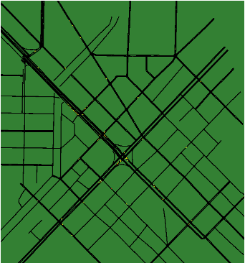 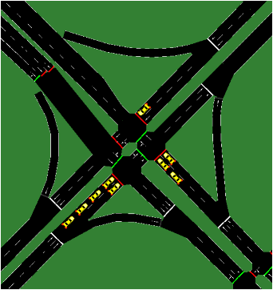

Fig. 3. Map used for simulation

**3.1 Simulation Results**

The simulation begins with an empty simulation of the map mentioned in figure 3. The empty simulation using NS2 is mentioned below in figure 4.

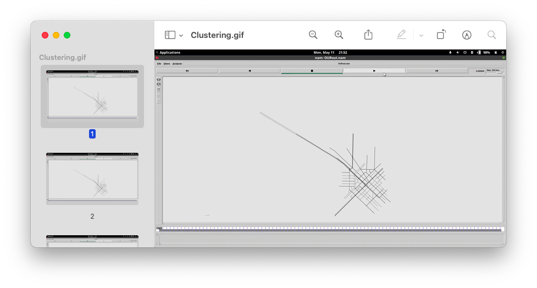

Fig. 4. Empty Simulation

In figure 5, one can see, as the vehicles transmit data, clusters are being formed and all have a similar colour to specify the clusters that they are a part of, and one can also see, a car which is very far from the main point (in figure 6) is also being able to join a cluster, which is the power of multi hopping, providing deeper penetration to an adhoc network which is stable as well.

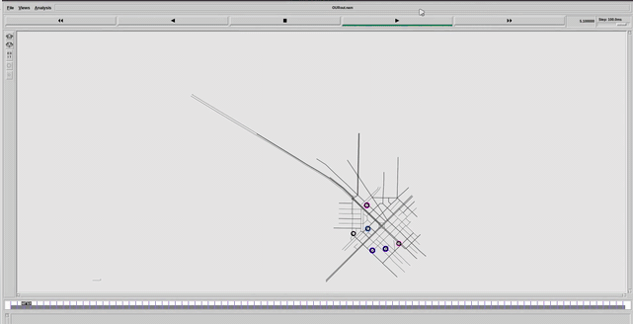

Fig. 5. Cluster formation in nearby vehicles

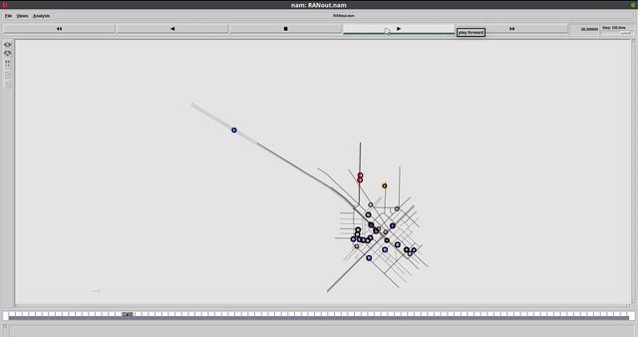

Fig. 6. Cluster Formation in faraway vehicle due to multi hopping

**3.2 Performance Comparison**

In the experiment, the proposed algorithm, Maximum Predicted Connection Survival time algorithm (MPCS) is being compared to three different algorithm of multihopping to find out the performance gains. The algorithms used for comparison are,

1. Lowest Identification Clustering (LID),
2. High Connectivity Clustering (HCC) and
3. Maximum Packet Collection (MPC)

Among them, the LID method uses the node with the smallest identification code as the CH. Its advantage is that it is easy to select the CH, but it is easy to increase the number of clusters.

The HCC approach uses the node with the most connections as the CH. If the number of connections is the same, the LID is used as the CH. The advantage can reduce the total number of clusters, but the nodes near the maximum transmission range may often leave and enter the transmission range, resulting in transmission quality low.

The MPC method is based on the invitation packets received. Nodes will preferentially join the cluster that receives the most invitation packets. The advantage is that the currently selected cluster is the cluster with the best communication quality, but it may be unstable due to changes in the driving environment.

The performance will be based on the following attributes,

1. Cumulative number of cluster heads and infrastructure disconnection,
2. Cumulative number of clusters,
3. Cumulative average survival time of the first cluster,
4. Cumulative average number of members.

**3.2.1 Cumulative number of cluster heads and infrastructure disconnection**

This Figure below (figure 7) shows the cumulative number of disconnections between cluster heads and infrastructure over time.

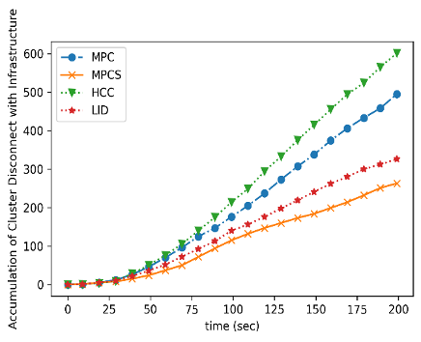

Fig. 7. cumulative number of disconnections between cluster heads and infrastructure

Since the cost of establishing a connection between the cluster and the infrastructure is much higher than that of establishing a connection between vehicles, the more disconnections between the cluster and the infrastructure, the worse the connection quality between the cluster and the infrastructure. If the number of disconnections between clusters and infrastructure can be reduced, the transmission efficiency of V2I can be improved.

In the figure 7, HCC has the worst performance. Due to the characteristics of HCC, large clusters will slowly expand over time, while small clusters will become smaller and smaller. If the node near the maximum connection range is added to the cluster, it is easy to leave the range, and a new cluster is created after leaving the range, but the cluster is added soon, this behaviour will cause a lot of additional costs. The best performance in the figure is the MPCS algorithm, which shows that the Cluster Selection CS algorithm is quite effective in predicting the best cluster.

**3.2.2 Cumulative number of clusters**

As the number of clusters is smaller, the advantages of clustering are more obvious, the interference to the vicinity of the infrastructure is also less, and the redundant information between vehicles can also be greatly reduced.

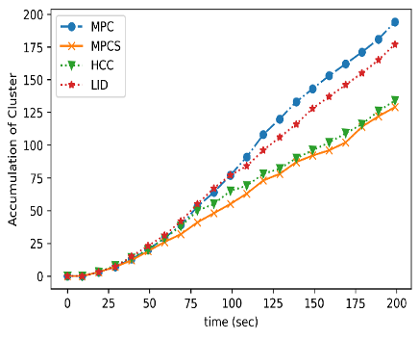

Fig. 8. time vs. average number of cluster members

From the time vs. average number of cluster members in the figure above (figure 8), inference can be made that MPCS and HCC have a significant effect in reducing the number of clusters, MPC does not deliberately reduce the number of clusters, but only considers the communication quality between nodes, and when selecting CH, LID will have a small range of nodes connected to the same with the smallest identification code. Therefore, the number of clusters is less than that of MPC, and least in MPCS.

**3.2.3 Cumulative average survival time of the first cluster**

The survival time of the cluster head will determine the connection time between the entire cluster and the infrastructure. If the survival time of the cluster head can be extended, the number of re-connections to the infrastructure will be reduced, thereby reducing unnecessary packet transmission.

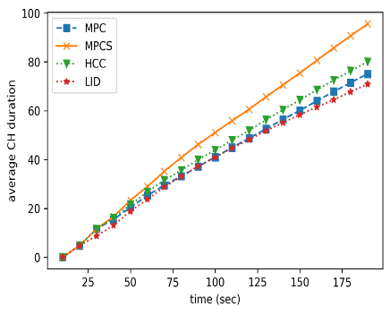

Fig. 9. Average survival time of clusters

Since the MPCS does not interfere with the selection of the cluster head, but only improves the connection quality of nodes other than the cluster head, the cluster head has fewer changes, and only the poor connection quality with the infrastructure leads to disconnection. It can be seen from the figure 9 that MPCS has the best performance in extending the connection time between the cluster head and the infrastructure.

**3.2.4 Cumulative average number of members**

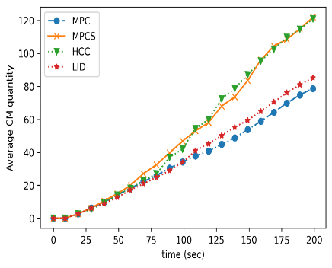

Fig. 10. Average number of members

Since all nodes choose the node with the best connection quality to themselves when choosing the parent, the greater the number of cluster members before the cluster member limit is exceeded, the more helpful it is to reduce the overall redundant packets and connection interference. It also means that the advantages brought by clustering are more obvious.

It can be seen from figure 10, that among the average number of cumulative cluster members, the MPCS and HCC algorithms have the best results. The same data of the infrastructure may require multiple transmissions to be successful, and larger clusters also require more time to transmit traffic data, which will increase the possibility of retransmission, while MPCS will have fewer disconnections. The impact is small.

**Chapter - 4**

**CONCLUSION**

In this study, a greedy algorithm has been proposed which is the maximum predicted connection survival algorithm (MPCS), based on a hierarchical structure. In order to provide vehicles that can dynamically select clusters while driving, and reduce the additional costs incurred by the clustering process while multi hopping delivery system is in use. LLT-based predictive quantitative indicators are used in cluster selection, and the angle of travel direction and the reward and penalty for connection prediction of the same cluster are introduced to provide a basis for vehicle cluster selection.

Moving further, the clustering strategy can further be improved as well as the forecasting method, so that the best cluster can be selected for driving, and the probability of cluster change will be reduced to meet the efficiency requirements of VANET.

**References**

[1] H. Moustafa and Y. Zhang, Vehicular Networks: Techniques, Standards, and Applications, 1st ed. Boston, MA, USA: Auerbach Publications, 2009.

[2] X. Cheng, L. Yang, and X. Shen, “D2D for intel-ligent transportation systems: A feasibility study,” IEEE Trans. Intell. Transp. Syst., vol. 16, no. 4, pp. 1784–1793, Aug. 2015.

[3] R. S. Bali, N. Kumar and J. J. Rodrigues, "Clus-tering in vehicular ad hoc networks: Taxonomy challenges and solutions", Veh. Commun., vol. 1, no. 3, pp. 134-152, 2014.

[4] C. Cooper, D. Franklin, M. Ros, F. Safaei, and M. Abolhasan, “A comparative survey of VANET clustering techniques,” IEEE Communications Surveys & Tutorials, vol. 99, p. 1, 2017.

[5] M.Newlin Rajkumar, M.Nithya, and P.HemaLatha, OVERVIEW OF VANET WITH ITS FEATURES AND SECURITY ATTACKS, International Research Journal of Engineering and Technology (IRJET), vol. 3, Jan. 2016

[6] Mengying Ren, Jun Zhang, Lyes Khoukhi, Hou-da Labiod, and Véronique Vèque. A Uniﬁed Framework of Clustering Approach in Vehicular Ad Hoc Networks. IEEE Transactions on Intelli-gent Transportation Systems, IEEE, 19 (5), pp.1401-1414, May. 2018.

[7] Xiang Ji, Huiqun Yu, Guisheng Fan, Huaiying Sun, and Liqiong Chen. Efficient and Reliable Cluster-Based Data Transmission for Vehicular Ad Hoc Networks. Hindiawi, Mobile Information Systems, DOI: 10.1155/2018/9826782 , July 2018.

[8] S. S. Wang and Y. S. Lin, “PassCAR: a passive clustering aided routing protocol for vehicular ad hoc networks,” Computer Communications, vol. 36, no. 2, pp. 170–179, 2013.

[9] S. Ucar, S. C. Ergen, and O. Ozkasap, “Multi-hop-cluster-based IEEE 802.11p and LTE hybrid architecture for VANET safety message dissemi-nation,” IEEE Transactions on Vehicular Tech-nology, vol. 65, no. 4, pp. 2621–2636, 2016.

[10] M. Gerla and J. T. C. Tsai, “Multiuser, mobile, multimedia radio network,” Wireless Network, vol. 1, pp.255–265, Oct. 1995.

[11] OpenStreetMap, 2017, http://www.openstreetmap.org/.

[12] SUMO: Simulation of Urban Mobility, 2015, http://sumo.sourceforge.net.

[13] The Network Simulator: NS2, 2015, http://www.isi.edu/nsnam/ns/.

[14] Teerawat Issariyakul, and Ekram Hossain (2012). Introduction to Network Simulator NS2. USA: Springer